# LAPORAN

**Praktikum Pemrograman WEB**

**Nama : Arif Muhammad Ihsan Marbun**

**Kelas : 1 D4 Teknik Informatika A**

**NRP : 3124600001**

1. Lopping and if else

1. If statement satu kondisi

1. if else statement dua kondisi

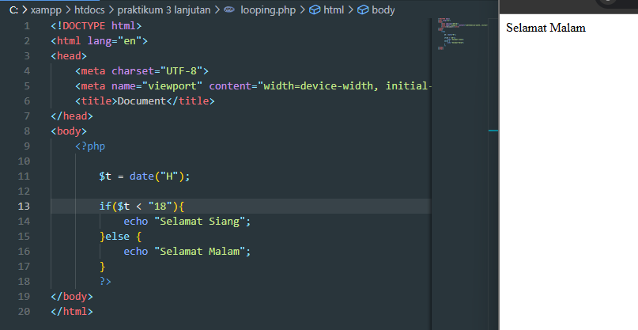

1. If elseif statement

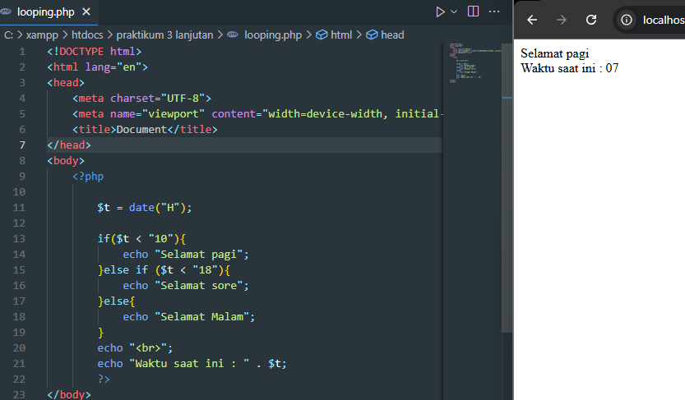

1. Switch Statement

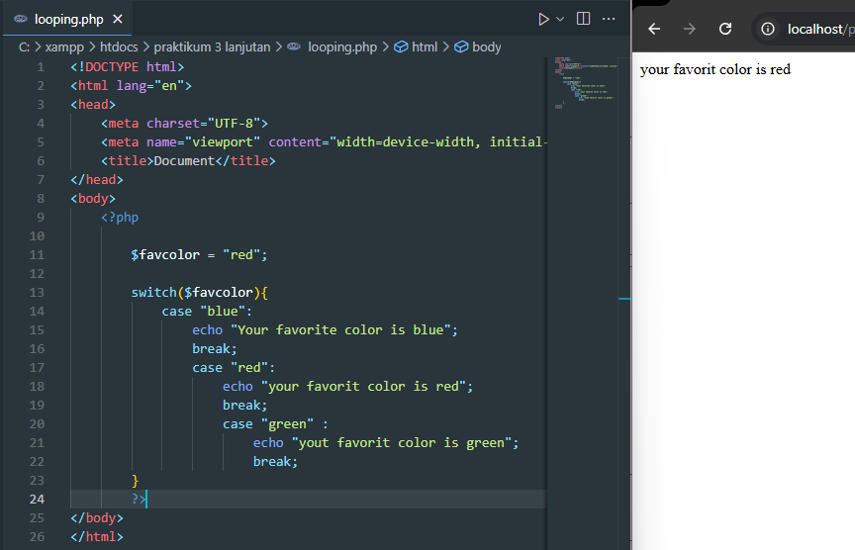

1. For Loop

1. while Loop

1. Workshop
2. Deret Fibonacci

1. Menampilkan Deret Bilangan Prima.

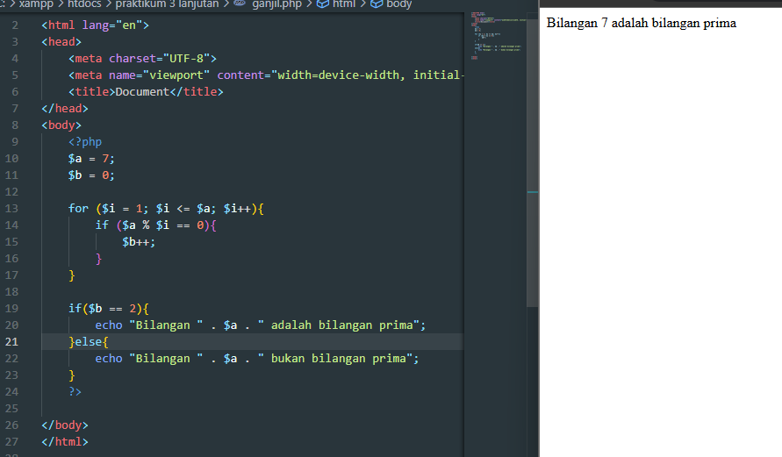

1. program untuk menampilkan tanggal dari komputer anda (format date pada komputer harus English(US)) dan melakukan konversi kedalam bahasa indonesia dengan contoh format “Rabu, 11 Agustus 2016”.

|  |
| --- |
| <!DOCTYPE html>  <html lang="en">  <head>      <meta charset="UTF-8">      <meta name="viewport" content="width=device-width, initial-scale=1.0">      <title>Document</title>  </head>  <body>      <?php      $tanggal = date("l, j F Y");      $nama_hari = array("Monday" => "Senin", "Tuesday" => "Selasa", "Wednesday" => "Rabu", "Thursday" => "Kamis", "Friday" => "Jumat", "Saturday" => "Sabtu", "Sunday" => "Minggu");      $nama_bulan = array("January" => "Januari", "February" => "Februari", "March" => "Maret", "April" => "April", "May" => "Mei", "June" => "Juni", "July" => "Juli", "August" => "Agustus", "September" => "September", "October" => "Oktober", "November" => "November", "December" => "Desember");      $tanggal_indonesia = $nama_hari[date("l")] . ", " . date("j") . " " . $nama_bulan[date("F")] . " " . date("Y");      echo $tanggal_indonesia;        ?>  </body>  </html> |

